The following subsections contain a list of short descriptions for many of the directives included in httpd.conf. These descriptions are not exhaustive. For more information, refer to the Apache documentation online at http://httpd.apache.org/docs/2.2/.

=================================000000=================================
=================================000000=================================

ServerRoot : The ServerRoot directive specifies the top-level directory containing website content.

ServerRoot "/usr/local/webs/apache-2.2.22"

=================================000000=================================
=================================000000=================================

ServerSignature : The ServerSignature directive adds a line containing the Apache HTTP Server version and the ServerName to any server-generated documents, such as error messages sent back to clients. ServerSignature is set to on by default.
ServerSignature can be set to EMail which adds a mailto:ServerAdmin HTML tag to the signature line of auto-generated responses. ServerSignature can also be set to Off to stop Apache from sending out its version number and module information. Please also check the ServerTokens settings.

ServerSignature Off

=================================000000=================================
=================================000000=================================

ServerTokens : The ServerTokens directive determines if the Server response header field sent back to clients should include details of the Operating System type and information about compiled-in modules. By default, ServerTokens is set to Full which sends information about the Operating System type and compiled-in modules. Setting the ServerTokens to Prod sends the product name only and is recommended as many hackers check information in the Server header when scanning for vulnerabilities. You can also set the ServerTokens to Min (minimal) or to OS (operating system).

ServerTokens Prod

=================================000000=================================
=================================000000=================================

PidFile : PidFile names the file where the server records its process ID (PID) identification number when it starts. By default the PID is listed in /var/run/httpd.pid.

PidFile /usr/local/webs/apache-2.2.22/logs/httpd.pid

=================================000000=================================
=================================000000=================================

Listen : The Listen command identifies the ports on which the Web server accepts incoming requests. By default, the Apache HTTP Server is set to listen to port 80 for non-secure Web communications and (in the /etc/httpd/conf.d/ssl.conf file which defines any secure servers) to port 443 for secure Web communications.

If the Apache HTTP Server is configured to listen to a port under 1024, only the root user can start it. For port 1024 and above, httpd can be started as a regular user.
The Listen directive can also be used to specify particular IP addresses over which the server accepts connections.

#Listen 12.34.56.78:80
#Listen 80
#Listen 8080
#Listen 443

=================================000000=================================
=================================000000=================================

TimeOut : Use this directive to specify the time at which the Apache Web server will no longer wait to accept a response from the client. When the time specified in the Timeout directive is exceeded, the connection with the client is closed. The time specified in the Timeout directive is applicable in the following situations:

Timeout 120
Timeout 300
- The time taken to receive a GET request from the client after a connection is established.
- Time taken to receive one TCP packet after another using POST and PUT HTTP requests, where the Web server is accepting a stream of data from the client after the connection is established.
- Time taken to receive acknowledgement for the TCP packets sent to the client after the Web server receives the request.
The time specified in the Timeout directive is applicable to all the preceding conditions. The default value specified for this directive is 300 seconds, which is more than enough time for the server to wait before closing the connection. The time specified in the Timeout directive can be safely reduced to 60 seconds. By specifying 60 seconds as the time-out period, you will avoid client connections that are particularly slow. However, 60 seconds is a long time to wait in today’s Internet atmosphere!
=================================000000=================================
=================================000000=================================

KeepAlive : HTTP /1.1 has a feature known as persistent connections that is supported by the Apache Web server. You use the KeepAlive directive to specify whether persistent connections should be allowed or not. This is a simple directive that can have a value of on or off. If you want Apache to use persistent connections, you need to specify the value on for this directive.

KeepAlive On

Note : Persistent connections is a feature of the HTTP /1.1 protocol that is used by all HTTP /1.1-compliant browsers to send requests to the Web server. This highly useful feature enables the browser to send multiple requests over a single connection, which greatly increases the download speed. Imagine that you want to download a Web page that has several graphics, audio, and video files. With only a single connection from the client, you can request each of the inline documents separately.

=================================000000=================================
=================================000000=================================

KeepAliveTimeout : The client uses the HTTP Keep-Alive header to indicate to the Web server that it requires a persistent connection. After the Web server receives this header, it waits for a subsequent request from the same client. The time that the Web server waits before closing the connection is specified in the KeepAliveTimeout directive.

The default time specified for this directive in the httpd.conf file is 15 seconds. After a lapse of 15 seconds, the Apache Web server processes the request already received from the client and then closes the connection.

KeepAliveTimeout 15

=================================000000=================================
=================================000000=================================

MaxKeepAliveRequests : When a persistent connection is established, the client is able to place multiple requests on a single connection. You use the MaxKeepAliveRequests directive to specify the number of requests that should be allowed per connection. By default, the value specified for this directive is 100, which means that for each persistent connection, a client can send 100 requests to the Web server.

MaxKeepAliveRequests 100

It is possible to set a value of 0 for the MaxKeepAliveRequests directive. However, doing so will mean that you are allowing an unlimited number of requests per connection. This is not advisable from performance and security points of view. An unlimited number of requests on a single connection can result in poor performance of the Web server. In addition, individuals with malicious intent could exploit it. So, it is best to keep the default value for this directive.

=================================000000=================================
=================================000000=================================

ServerAdmin : Sets the ServerAdmin directive to the email address of the Web server administrator. This email address shows up in error messages on server-generated Web pages, so users can report a problem by sending email to the server administrator.
By default, ServerAdmin is set to root@localhost.
A common way to set up ServerAdmin is to set it to webmaster@example.com. Once set, alias webmaster to the person responsible for the Web server in /etc/aliases and run /usr/bin/newaliases.

ServerAdmin websupport@altisource.com
=================================000000=================================
=================================000000=================================
ServerName : ServerName specifies a hostname and port number (matching the Listen directive) for the server. The ServerName does not need to match the machine's actual hostname. For example, the Web server may be www.example.com, but the server's hostname is actually foo.example.com. The value specified in ServerName must be a valid Domain Name Service (DNS) name that can be resolved by the system — do not make something up.
The following is a sample ServerName directive: ServerName www.example.com:80

When specifying a ServerName, be sure the IP address and server name pair are included in the /etc/hosts file.

ServerName www.example.com:80
ServerName 192.168.82.47:80

=================================000000=================================
=================================000000=================================

UseCanonicalName : In many situations Apache must construct a self-referential URL -- that is, a URL that refers back to the same server. With UseCanonicalName On Apache will use the hostname and port specified in the ServerName directive to construct the canonical name for the server. This name is used in all self-referential URLs, and for the values of SERVER_NAME and SERVER_PORT in CGIs.

With UseCanonicalName Off Apache will form self-referential URLs using the hostname and port supplied by the client if any are supplied (otherwise it will use the canonical name, as defined above). These values are the same that are used to implement name based virtual hosts, and are available with the same clients. The CGI variables SERVER_NAME and SERVER_PORT will be constructed from the client supplied values as well.

An example where this may be useful is on an intranet server where you have users connecting to the machine using short names such as www. You'll notice that if the users type a shortname, and a URL which is a directory, such as http://www/splat, without the trailing slash then Apache will redirect them to http://www.domain.com/splat/. If you have authentication enabled, this will cause the user to have to authenticate twice (once for www and once again for www.domain.com -- see the FAQ on this subject for more information). But if UseCanonicalName is set Off, then Apache will redirect to http://www/splat/.

There is a third option, UseCanonicalName DNS, which is intended for use with mass IP-based virtual hosting to support ancient clients that do not provide a Host: header. With this option Apache does a reverse DNS lookup on the server IP address that the client connected to in order to work out self-referential URLs.

UseCanonicalName Off
=================================000000=================================
=================================000000=================================

DocumentRoot : The directory out of which you will serve your documents. By default, all requests are taken from this directory, but links and aliases may be used to point to other locations.

DocumentRoot "/usr/local/webs/apache-2.2.22/htdocs"

To change the DocumentRoot so that it is not shared by the secure and the non-secure Web servers, refer to “Virtual Hosts”.

<VirtualHost *:80>
DocumentRoot /usr/local/webs/apache-2.2.22/htdocs

<VirtualHost *:443>
DocumentRoot /usr/local/webs/apache-2.2.22/htdocs

=================================000000=================================
=================================000000=================================

LoadModule : LoadModule is used to load Dynamic Shared Object (DSO) modules at server startup or restart.

LoadModule include_module modules/mod_include.so
LoadModule mem_cache_module modules/mod_mem_cache.so
LoadModule status_module modules/mod_status.so
LoadModule proxy_http_module modules/mod_proxy_http.so

=================================000000=================================
=================================000000=================================

Dynamic Shared Object (DSO) Support : To be able to use the functionality of a module which was built as a DSO you have to use corresponding `LoadModule' so the directives contained in it are actually available _before_ they are used. Statically compiled modules (those listed by `httpd -l') do not need to be loaded here.

The DSO support for loading individual Apache modules is based on a module named mod_so which must be statically compiled into the Apache core. It is the only module besides core which cannot be put into a DSO itself. Practically all other distributed Apache modules can then be placed into a DSO by individually enabling the DSO build for them via configure's --enable-module=shared option. After a module is compiled into a DSO named mod_foo.so you can use mod_so's LoadModule command in your httpd.conf file to load this module at server startup or restart.

To simplify this creation of DSO files for Apache modules (especially for third-party modules) a new support program named apxs (APache eXtenSion) is available. It can be used to build DSO based modules outside of the Apache source tree.

The idea is simple: When installing Apache the configure's make install procedure installs the Apache C header files and puts the platform-dependent compiler and linker flags for building DSO files into the apxs program. This way the user can use apxs to compile his Apache module sources without the Apache distribution source tree and without having to fiddle with the platform-dependent compiler and linker flags for DSO support.

Usage Summary : To give you an overview of the DSO features of Apache 2.x, here is a short and concise summary:

1. Build and install a distributed Apache module, say mod_foo.c, into its own DSO mod_foo.so:

2. Build and install a third-party Apache module, say mod_foo.c, into its own DSO mod_foo.so:

3. Configure Apache for later installation of shared modules:

4. Build and install a third-party Apache module, say mod_foo.c, into its own DSO mod_foo.so outside of the Apache source tree using apxs:

In all cases, once the shared module is compiled, you must use a LoadModule directive in httpd.conf to tell Apache to activate the module.

=================================000000=================================
=================================000000=================================

IfModule :
<IfModule dir_module>
DirectoryIndex index.html
</IfModule>
This tags create a conditional container which are only activated if the specified module is loaded. Directives within the IfModule container are processed under one of two conditions.
- The directives are processed if the module contained within the starting <IfModule> tag is loaded. Or
- If an exclamation point ! appears before the module name, the directives are processed only if the module specified in the <IfModule> tag is not loaded.
<IfModule !mpm_netware_module>
<IfModule !mpm_winnt_module>
SetEnv proxy-initial-not-pooled 1
User webserv
Group webserv
</IfModule>
</IfModule>
=================================000000=================================
=================================000000=================================

User/Group: The name (or #number) of the user/group to run httpd as. It is usually good practice to create a dedicated user and group for running httpd, as with most system services.

=================================000000=================================
=================================000000=================================

proxy-initial-not-pooled : If this variable is set no pooled connection will be reused if the client connection is an initial connection. This avoids the "proxy: error reading status line from remote server" error message caused by the race condition that the backend server closed the pooled connection after the connection check by the proxy and before data sent by the proxy reached the backend. It has to be kept in mind that setting this variable downgrades performance, especially with HTTP/1.0 clients.

=================================000000=================================
=================================000000=================================

SetEnv : Sets an internal environment variable, which is then available to Apache HTTP Server modules, and passed on to CGI scripts and SSI pages.

SetEnv proxy-initial-not-pooled 1

The internal environment variables set by this directive are set after most early request processing directives are run, such as access control and URI-to-filename mapping. If the environment variable you're setting is meant as input into this early phase of processing such as the RewriteRule directive, you should instead set the environment variable with SetEnvIf.

=================================000000=================================
=================================000000=================================

SetEnvIf : SetEnvIf sets environment variables based on the headers of incoming connections. It is not solely an SSL directive, though it is present in the supplied /etc/httpd/conf.d/ssl.conf file. It's purpose in this context is to disable HTTP keepalive and to allow SSL to close the connection without a closing notification from the client browser. This setting is necessary for certain browsers that do not reliably shut down the SSL connection.

Do not log requests for images in the access log : This example keeps requests for images from appearing in the access log. It can be easily modified to prevent logging of particular directories, or to prevent logging of requests coming from particular hosts.

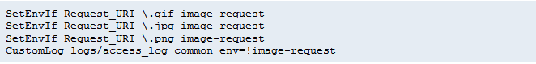
Prevent "Image Theft" : This example shows how to keep people not on your server from using images on your server as inline-images on their pages. This is not a recommended configuration, but it can work in limited circumstances. We assume that all your images are in a directory called /web/images.
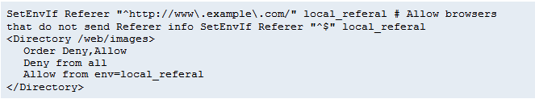

=================================000000=================================
=================================000000=================================

Directory : directive allows you to specify settings and directives to apply to directories and sub-directories. This gives you the ability to do all sorts of things, such as limiting access to certain directories and files, and turning on or off certain options to certain directories, among other things.

The <Directory> tags take a path and enclose a block of options to be applied to that directory and its sub-directories. Here is an example:

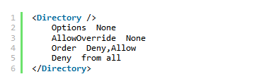

The opening <Directory> tag in this example specifies a path of /, which means the root directory and all its sub-directories and files. The settings defined inside the <Directory> tags apply to the / path (essentially everything in the root).

The Options directive declares which server features are valid for the specified directory. In this example, no options are valid for the / path. But you could specify any number of options, like allowing symbolic links, allowing the execution of CGI scripts, allowing server-side includes, and many more.
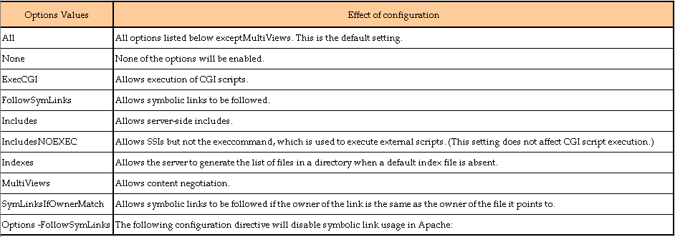
The AllowOverride directive tells the server which settings declared within the <Directory> tags to override if they are reset in the .htaccess file. When the server finds an .htaccess file, it needs to know which directives declared in that file can override earlier configuration directives. If AllowOverride is set to None, as shown in the example above, then no directives are overridden and any re-declarations in the .htaccess files are completely ignored.

Note : htaccess is not an extension; it is the file’s name.

If the AllowOverride directive is set to All, then any directive re-declared in the .htaccess file will override earlier configuration directives. AllowOverride can take specific directive types that can be overridden while the rest will be ignored.

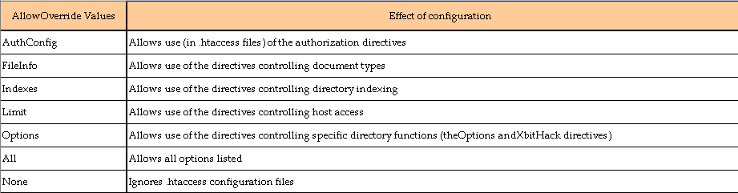

Deny and Allow control access to the directory specified within the opening tag, and are prioritized through the Order directive.

In the above example,
Order Deny, Allow means all connecting hosts or IP addresses are denied access to the root directory, except those declared as good hosts.
Order Allow, Deny on the other hand would mean that all hosts and IPs are to be allowed access to the root directory except those declared as bad or black-listed.

The Deny from all setting declares that access needs to be denied from all hosts. Since it is not followed by a whitelist, no hosts or IPs have access to the root directory (and this is how it should be for security reasons).

For demonstration purposes ONLY, the below example demonstrates how to deny access from all hosts except www.goodhost1.com and www.goodhost2.com:

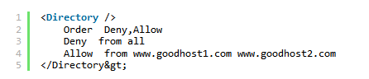

Note that the Order directive defines the precedence of the rules. So, first, we deny access from all hosts, and then we only allow access to both www.goodhost1.com and www.goodhost2.com. Alternatively, you can specify the two hosts on a separate line like this:
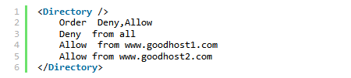

If you want to allow access to all sub-domains of the host goodhost.com (eg: sub1.goodhost.com, sub2.goodhost.com, and sub3.goodhost.com), you can specify a partial domain name to grant access to instead of listing all sub-domains to be allowed. The following example shows you how:

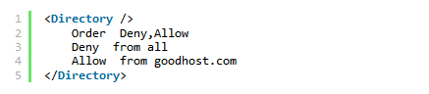

Additionally, if you want to deny access from all except a particular IP address on the local network, the following example illustrates how you could do that:
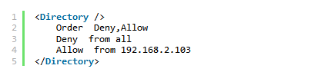

If you wanted to allow access to all hosts except for a few bad hosts, you could do something like this:
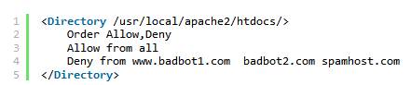

The above example opens the public directory to all connecting clients except for two bad bots and one spam host. Note the use of either the whole domain name or the partial domain name in the host blacklist.

Similar to <Directory> is <DirectoryMatch>. It encloses a group of directives that apply only to the named directory and its sub-directories. Instead of specifying a path, it takes a regular expression as an argument.

=================================000000=================================
=================================000000=================================
AccessFileName : AccessFileName names the file which the server should use for access control information in each directory. The default is .htaccess.

Steps to restrict users to accessing specific location:
- Create .htaccess file in the directory that you want to restrict users.
- Create .htpasswd file, place this file outside document root so that it is not viewable by clients.
htpasswd –c .htpasswd username
cat .htpasswd
- Change the httpd.conf file to restrict users or provide authentication based on access:
AllowOverride None ==> AllowOverride AuthConfig
AccessFileName .htaccess

<Files “^\.ht”>
Order Allow, deny
Deny from all
</Files>

.htaccess files should be used in a case where the content providers need to make configuration changes to the server on a per-directory basis, but do not have root access on the server system.

However, in general, use of .htaccess files should be avoided when possible. Any configuration that you would consider putting in a .htaccess file, can just as effectively be made in a <Directory> section in your main server configuration file.

There are two main reasons to avoid the use of .htaccess files.

The first of these is performance. When AllowOverride is set to allow the use of .htaccess files, httpd will look in every directory for .htaccess files. Thus, permitting .htaccess files causes a performance hit, whether or not you actually even use them! Also, the .htaccess file is loaded every time a document is requested.

Further note that httpd must look for .htaccess files in all higher-level directories, in order to have a full complement of directives that it must apply. Thus, if a file is requested out of a directory /www/htdocs/example, httpd must look for the following files:

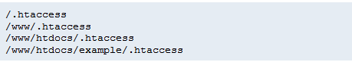

And so, for each file access out of that directory, there are 4 additional file-system accesses, even if none of those files are present.

The second consideration is one of security. You are permitting users to modify server configuration, which may result in changes over which you have no control.

Note that it is completely equivalent to put a .htaccess file in a directory /www/htdocs/example containing a directive, and to put that same directive in a Directory section <Directory /www/htdocs/example> in your main server configuration:

.htaccess file in /www/htdocs/example:

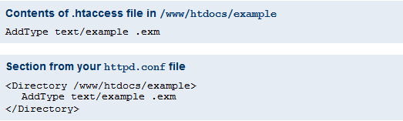

However, putting this configuration in your server configuration file will result in less of a performance hit, as the configuration is loaded once when httpd starts, rather than every time a file is requested.

The use of .htaccess files can be disabled completely by setting the AllowOverride directive to none:

AllowOverride None

=================================000000=================================
=================================000000=================================

Indexes and DirectoryIndex Directives : When you visit a website, you often just type in the domain name without the specifying a page (eg: www.example.com as opposed to www.example.com/index.html). The reason being because the server usually always gives you the default page.

This functionality is governed by the DirectoryIndex directive on the web server; it tells the server the default page to respond with if no file is specified in the URL.
DirectoryIndex can take multiple values (ie: more than one file name), so that when the server encounters a request that doesn’t specify a particular file, the server will go through the many values one by one until it finds a file with the same name in the requested directory.

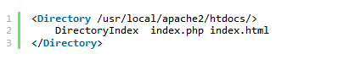

If a client asks for a directory that doesn’t contain any of the default files listed by the DirectoryIndex directive, the server responds with the directory listing, a list of all files and sub-directories contained within that folder. This could potentially be a security risk, as the files and file system structure of the requested directory are exposed. You can avoid this behavior by using the Indexes option to prevent directory listing on the DocumentRoot level (which is the root directory of the server’s htdocs or public files). If you wish to display folder listings for any sub-directory under the DocumentRoot, you can turn on the Indexes option for that particular folder. The following listing demonstrates this:
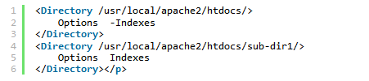

The above example turns off directory listings under the main public HTML folder (in this case /usr/local/apache2/htdocs/) and all sub-directories, and then turns it back on only for the /usr/local/apache2/htdocs/sub-dir1/ sub-directory.

=================================000000=================================
=================================000000=================================

File : While the <Directory> directive specifies the permissions or restrictions to be applied to a specific directory, the <Files> directive controls the restrictions and permissions for one or multiple files (wildcards must be used within a file name to specify multiple files). Take a look at this listing:

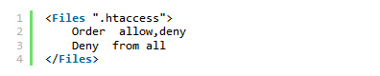

This example uses the <Files> directive to prevent .htaccess files from being viewed by web clients. The image below is a screenshot of what the server responds if you try to retrieve the .htaccess file by requesting something like http://www.example.com/.htaccess

Similarly, the <FilesMatch> directive limits the scope of the enclosed directives by file name, just as the <Files> directive does. However, it accepts a regular expression as an argument.

=================================000000=================================
=================================000000=================================

Location : directive works similar to the <Directory> directive except that it takes a URL as an argument, as opposed to a path to a local physical directory in the file system. This means that <Location> can be used to control content outside the server.

<Location /server-status>
SetHandler server-status
Order deny, allow
Deny from all
Allow from .example.com
</Location>

It is highly advised that you don’t use the <Location> directive with local file system locations, because many URLs may map to the same file.
The <LocationMatch> directive also limits the scope of the enclosed directives by URL. Like the other “Match” directives, it accepts a regular expression as an argument.

=================================000000=================================
=================================000000=================================

Limit : directive controls which HTTP methods (eg: GET, POST, etc) are allowed. As seen in the example below, the <Limit> directive denies the use of the POST, PUT, and DELETE methods to all client requests, except for those originating from 50.57.77.153.

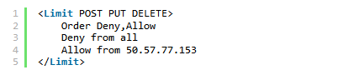

The <LimitExcept> directive provides the opposite functionality. It still controls what HTTP methods are allowed, but it does so in an exclusionary manner. In the example below, <LimitExcept> denies access to all client requests using any HTTP methods other than GET and POST.

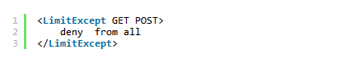

=================================000000=================================
=================================000000=================================

Alias : The Alias setting allows directories outside the DocumentRoot directory to be accessible. Any URL ending in the alias automatically resolves to the alias' path.

There are frequently circumstances where it is necessary to allow web access to parts of the filesystem that are not strictly underneath the DocumentRoot. Apache offers several different ways to accomplish this:
- On Unix systems, symbolic links can bring other parts of the filesystem under the DocumentRoot. For security reasons, Apache will follow symbolic links only if the Options setting for the relevant directory includes FollowSymLinks or SymLinksIfOwnerMatch.

- Alternatively, the Alias directive will map any part of the filesystem into the web space. For example, with

Alias /docs /var/web

The URL http://www.example.com/docs/dir/file.html will be served from /var/web/dir/file.html.

=================================000000=================================
=================================000000=================================
IfDefine : The IfDefine tags surround configuration directives that are applied if the "test" stated in the IfDefine tag is true. The directives are ignored if the test is false.
Note : The <IfDefine>, <IfModule>, and <IfVersion> containers, are evaluated only at server startup and restart. If their conditions are true at startup, then the enclosed directives will apply to all requests. If the conditions are not true, the enclosed directives will be ignored.

The <IfDefine> directive encloses directives that will only be applied if an appropriate parameter is defined on the httpd command line. For example, with the following configuration, all requests will be redirected to another site only if the server is started using following command:

$ httpd -DClosedForNow

httpd.conf
<IfDefine ClosedForNow>
Redirect / http://otherserver.example.com/
</IfDefine>

=================================000000=================================
=================================000000=================================

ErrorDocument : The ErrorDocument directive associates an HTTP response code with a message or a URL to be sent back to the client. By default, the Web server outputs a simple and usually cryptic error message when an error occurs. The ErrorDocument directive forces the Web server to instead output a customized message or page.

In the event of a problem or error, Apache can be configured to do one of four things,

- output a simple hardcoded error message
- output a customized message
- redirect to a local URL-path to handle the problem/error
- redirect to an external URL to handle the problem/error

The first option is the default, while options 2-4 are configured using the ErrorDocument directive, which is followed by the HTTP response code and a URL or a message. Apache will sometimes offer additional information regarding the problem/error.

URLs can begin with a slash (/) for local web-paths (relative to the DocumentRoot), or be a full URL which the client can resolve. Alternatively, a message can be provided to be displayed by the browser. Examples:

ErrorDocument 500 http://foo.example.com/cgi-bin/tester
ErrorDocument 404 /404_oc.html
ErrorDocument 500 /500_oc.html
ErrorDocument 503 /503_oc.html
ErrorDocument 403 "Sorry can't allow you access today"

=================================000000=================================
=================================000000=================================

Apache Logs

LogFormat : The LogFormat directive configures the format of the various Web server log files. The actual LogFormat used depends on the settings given in the CustomLog directive .

Common Log Format:
LogFormat "%h %l %u %t \"%r\" %>s %b" common
CustomLog logs/access_log common

Combined Log Format: This format is exactly the same as the Common Log Format, with the addition of two more fields.

LogFormat "%h %l %u %t \"%r\" %>s %b \"%{Referer}i\" \"%{User-agent}i\"" combined
CustomLog log/access_log combined

The log file entries produced in Combined Log Format will look something like this:

127.0.0.1 (%h) : This is the IP address of the client (remote host) which made the request to the server. If HostnameLookups is set to On, then the server will try to determine the hostname and log it in place of the IP address. However, this configuration is not recommended since it can significantly slow the server. Instead, it is best to use a log post-processor such as logresolve to determine the hostnames. The IP address reported here is not necessarily the address of the machine at which the user is sitting. If a proxy server exists between the user and the server, this address will be the address of the proxy, rather than the originating machine.

- (%l) : The "hyphen" in the output indicates that the requested piece of information is not available. In this case, the information that is not available is the RFC 1413 identity of the client determined by identd on the clients machine. This information is highly unreliable and should almost never be used except on tightly controlled internal networks. Apache httpd will not even attempt to determine this information unless IdentityCheck is set to On.

frank (%u) : This is the userid of the person requesting the document as determined by HTTP authentication. The same value is typically provided to CGI scripts in the REMOTE_USER environment variable. If the status code for the request (see below) is 401, then this value should not be trusted because the user is not yet authenticated. If the document is not password protected, this part will be "-" just like the previous one.

[10/Oct/2000:13:55:36 -0700] (%t) : The time that the request was received. The format is:
[day/month/year:hour:minute:second zone]
day = 2*digit
month = 3*letter
year = 4*digit
hour = 2*digit
minute = 2*digit
second = 2*digit
zone = (`+' | `-') 4*digit

It is possible to have the time displayed in another format by specifying %{format}t in the log format string, where format is as in strftime(3) from the C standard library.
"GET /apache_pb.gif HTTP/1.0" (\"%r\") : The request line from the client is given in double quotes. The request line contains a great deal of useful information. First, the method used by the client is GET. Second, the client requested the resource /apache_pb.gif, and third, the client used the protocol HTTP/1.0. It is also possible to log one or more parts of the request line independently. For example, the format string "%m %U%q %H" will log the method, path, query-string, and protocol, resulting in exactly the same output as "%r".

200 (%>s) : This is the status code that the server sends back to the client. This information is very valuable, because it reveals whether the request resulted in a successful response (codes beginning in 2), a redirection (codes beginning in 3), an error caused by the client (codes beginning in 4), or an error in the server (codes beginning in 5). The full list of possible status codes can be found in the HTTP specification (RFC2616 section 10).

2326 (%b) : The last part indicates the size of the object returned to the client, not including the response headers. If no content was returned to the client, this value will be "-". To log "0" for no content, use %B instead.

"http://www.example.com/start.html" (\"%{Referer}i\") : The "Referer" (sic) HTTP request header. This gives the site that the client reports having been referred from. (This should be the page that links to or includes /apache_pb.gif).

"Mozilla/4.08 [en] (Win98; I ;Nav)" (\"%{User-agent}i\") : The User-Agent HTTP request header. This is the identifying information that the client browser reports about itself.

=================================000000=================================
=================================000000=================================

CustomLog : Sets filename and format of log file, CustomLog identifies the log file and the log file format.

CustomLog log/access_log combined
CustomLog log/access_log common

http://httpd.apache.org/docs/2.2/mod/mod_log_config.html

=================================000000=================================
=================================000000=================================

ErrorLog : The ErrorLog directive sets the name of the file to which the server will log any errors it encounters. If the file-path is not absolute then it is assumed to be relative to the ServerRoot.

ErrorLog /var/log/httpd/error_log
ErrorLog "logs/error_log"
=================================000000=================================
=================================000000=================================

LogLevel : LogLevel adjusts the verbosity of the messages recorded in the error logs. The following levels are available, in order of decreasing significance:

When a particular level is specified, messages from all other levels of higher significance will be reported as well. E.g., when LogLevel info is specified, then messages with log levels of notice and warn will also be posted.
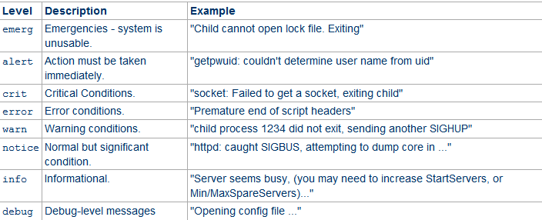

=================================000000=================================
=================================000000=================================

Include : Include allows other configuration files to be included at runtime.
The path to these configuration files can be absolute or relative to the ServerRoot.

Include conf/extra/mod-jk.conf
Include conf/extra/httpd-mpm.conf
Include conf/extra/httpd-vhosts.conf

=================================000000=================================
=================================000000=================================

Multi-Processing Module ( MPM )
Apache 2.0 extends the modular design to the most basic functions of a web server. The server ships with a selection of Multi-Processing Modules (MPMs) which are responsible for binding to network ports on the machine, accepting requests, and dispatching children to handle the requests.

MPMs must be chosen during configuration, and compiled into the server. Compilers are capable of optimizing a lot of functions if threads are used, but only if they know that threads are being used.
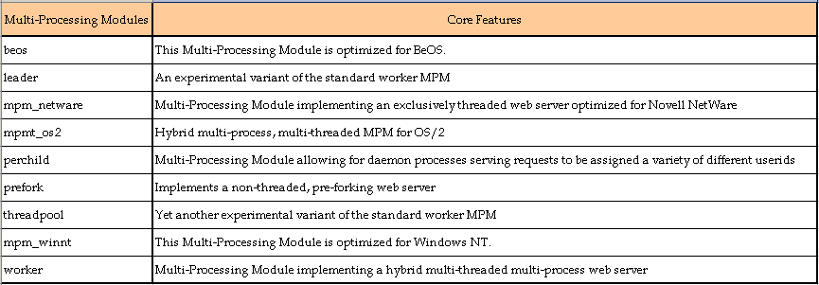
There are a number of MPM modules, but by far the most widely used (at least on *nix platforms) are the three main ones: prefork, worker, and event.

prefork mpm_prefork : It's compatible with everything, it spins of a number of child processes for serving requests, and the child processes only serve one request at a time. Because it's got the server process sitting there, ready for action, and not needing to deal with thread marshaling, it's actually faster than the more modern threaded MPMs when you're only dealing with a single request at a time - but concurrent requests suffer, since they're made to wait in line until a server process is free. Additionally, attempting to scale up in the count of prefork child processes, will cause serious RAM constraints.

It's probably not advisable to use prefork unless you need a module that's not thread safe.

Use if: You need modules that break when threads are used, like mod_php. Even then, consider using FastCGI and php-fpm.

Don't use if: Your modules won't break in threading.

=======================================================================

worker mpm_worker : Uses threading - which is a big help for concurrency. Worker spins off some child processes, which in turn spin off child threads; similar to prefork, some spare threads are kept ready if possible, to service incoming connections. This approach is much kinder on RAM, since the thread count doesn't have a direct bearing on memory use like the server count does in prefork. It also handles concurrency much more easily, since the connections just need to wait for a free thread (which is usually available) instead of a spare server in prefork.

Use if: You're on Apache 2.2, or 2.4 and you're running primarily SSL.

Don't use if: You really can't go wrong, unless you need prefork for compatibility.

However, note that the treads are attached to connections and not requests - which means that a keep-alive connection always keeps a hold of a thread until it's closed (which can be a long time, depending on your configuration). Which is why we have.. Event

=======================================================================

event mpm_event : It is very similar to worker, structurally; it's just been moved from 'experimental' to 'stable' status in Apache 2.4. The big difference is that it uses a dedicated thread to deal with the kept-alive connections, and hands requests down to child threads only when a request has actually been made (allowing those threads to free back up immediately after the request is completed). This is great for concurrency of clients that aren't necessarily all active at a time, but make occasional requests, and when the clients might have a long keep-alive timeout.

The exception here is with SSL connections; in that case, it behaves identically to worker (gluing a given connection to a given thread until the connection closes).

Use if: You're on Apache 2.4 and like threads, but you don't like having threads waiting for idle connections. Everyone likes threads!

Don't use if: You're not on Apache 2.4, or you need prefork for compatibility.

=======================================================================

Apache MPM worker
This Multi-Processing Module (MPM) implements a hybrid multi-process multi-threaded server. By using threads to serve requests, it is able to serve a large number of requests with fewer system resources than a process-based server. However, it retains much of the stability of a process-based server by keeping multiple processes available, each with many threads.

The most important directives used to control this MPM are:
ThreadsPerChild : which controls the number of threads deployed by each child process. MaxClients : which controls the maximum total number of threads that may be launched.

How it Works
A single control process (the parent) is responsible for launching child processes. Each child process creates a fixed number of server threads as specified in the ThreadsPerChild directive, as well as a listener thread which listens for connections and passes them to a server thread for processing when they arrive.

- Apache always tries to maintain a pool of spare or idle server threads, which stand ready to serve incoming requests. In this way, clients do not need to wait for a new threads or processes to be created before their requests can be served.

- The number of processes that will initially launched is set by the StartServers directive.

- During operation, Apache assesses the total number of idle threads in all processes, and forks or kills processes to keep this number within the boundaries specified by MinSpareThreads and MaxSpareThreads.

- Since this process is very self-regulating, it is rarely necessary to modify these directives from their default values.

- The maximum number of clients that may be served simultaneously (i.e., the maximum total number of threads in all processes) is determined by the MaxClients directive.

- The maximum number of active child processes is determined by the MaxClients directive divided by the ThreadsPerChild directive.

Two directives set hard limits on the number of active child processes and the number of server threads in a child process, and can only be changed by fully stopping the server and then starting it again.
ServerLimit is a hard limit on the number of active child processes, and must be greater than or equal to the MaxClients directive divided by the ThreadsPerChild directive.

ThreadLimit is a hard limit of the number of server threads, and must be greater than or equal to the ThreadsPerChild directive. If non-default values are specified for these directives, they should appear before other worker directives.

In addition to the set of active child processes, there may be additional child processes which are terminating, but where at least one server thread is still handling an existing client connection. Up to MaxClients terminating processes may be present, though the actual number can be expected to be much smaller. This behavior can be avoided by disabling the termination of individual child processes, which is achieved using the following:

•set the value of MaxRequestsPerChild to zero
•set the value of MaxSpareThreads to the same value as MaxClients

A typical configuration of the process-thread controls in the worker MPM could look as follows:

<IfModule mpm_worker_module>
ServerLimit 80
StartServers 4
MaxClients 4000
MinSpareThreads 50
MaxSpareThreads 150
ThreadsPerChild 50
MaxRequestsPerChild 1000
</IfModule>

While the parent process is usually started as root under Unix in order to bind to port 80, the child processes and threads are launched by Apache as a less-privileged user. The User and Group directives are used to set the privileges of the Apache child processes. The child processes must be able to read all the content that will be served, but should have as few privileges beyond that as possible.

The following section list directives found within the MPM-specific server-pool containers :

MaxClients : MaxClients sets a limit on the total number of server processes, or simultaneously connected clients, that can run at one time. The main purpose of this directive is to keep a runaway Apache HTTP Server from crashing the operating system. For busy servers this value should be set to a high value. The server's default is set to 150 regardless of the MPM in use. However, it is not recommended that the value for MaxClients exceeds 256 when using the prefork MPM.

MaxRequestsPerChild : MaxRequestsPerChild sets the total number of requests each child server process serves before the child dies. The main reason for setting MaxRequestsPerChild is to avoid long-lived process induced memory leaks. The default MaxRequestsPerChild for the prefork MPM is 4000 and for the worker MPM is 0.

MinSpareServers and MaxSpareServers : These values are only used with the prefork MPM. They adjust how the Apache HTTP Server dynamically adapts to the perceived load by maintaining an appropriate number of spare server processes based on the number of incoming requests. The server checks the number of servers waiting for a request and kills some if there are more than MaxSpareServers or creates some if the number of servers is less than MinSpareServers.
The default MinSpareServers value is 5; the default MaxSpareServers value is 20. These default settings should be appropriate for most situations. Be careful not to increase the MinSpareServers to a large number as doing so creates a heavy processing load on the server even when traffic is light.

MinSpareThreads and MaxSpareThreads : These values are only used with the worker MPM. They adjust how the Apache HTTP Server dynamically adapts to the perceived load by maintaining an appropriate number of spare server threads based on the number of incoming requests. The server checks the number of server threads waiting for a request and kills some if there are more than MaxSpareThreads or creates some if the number of servers is less than MinSpareThreads.
The default MinSpareThreads value is 25; the default MaxSpareThreads value is 75. These default settings should be appropriate for most situations. The value for MaxSpareThreads must be greater than or equal to the sum of MinSpareThreads and ThreadsPerChild, else the Apache HTTP Server automatically corrects it.
StartServers : The StartServers directive sets how many server processes are created upon startup. Since the Web server dynamically kills and creates server processes based on traffic load, it is not necessary to change this parameter. The Web server is set to start 8 server processes at startup for the prefork MPM and 2 for the worker MPM.

ThreadsPerChild : This value is only used with the worker MPM. It sets the number of threads within each child process. The default value for this directive is 25.

=================================000000=================================
=================================000000=================================

Apache Virtual Host
Virtual Host refers to the practice of running more than one web site (such as company1.example.com and company2.example.com) on a single machine. Virtual hosts can be:
- IP-based meaning that you have a different IP address for every web site
- Name-based meaning that you have multiple names running on each IP address.

The fact that they are running on the same physical server is not apparent to the end user. This can use almost any option normally used in the httpd.conf file, you can treat Virtual Host as individually customized httpd.conf

Name-based vs. IP-based Virtual Hosts
IP-based virtual hosts use the IP address of the connection to determine the correct virtual host to serve. Therefore you need to have a separate IP address for each host. With name-based virtual hosting, the server relies on the client to report the hostname as part of the HTTP headers. Using this technique, many different hosts can share the same IP address.

Name-based virtual hosting is usually simpler, since you need only configure your DNS server to map each hostname to the correct IP address and then configure the Apache HTTP Server to recognize the different hostnames. Name-based virtual hosting also eases the demand for scarce IP addresses. Therefore you should use name-based virtual hosting unless you are using equipment that explicitly demands IP-based hosting. Historical reasons for IP-based virtual hosting based on client support are no longer applicable to a general-purpose web server, unless you are using a mod_ssl version without SNI support (standard in Apache releases since 2.2.12).

If you are trying to debug your virtual host configuration, you may find the Apache -S command line switch useful. That is, type the following command: /usr/local/apache2/bin/httpd -S

This command will dump out a description of how Apache parsed the configuration file. Careful examination of the IP addresses and server names may help uncover configuration mistakes.
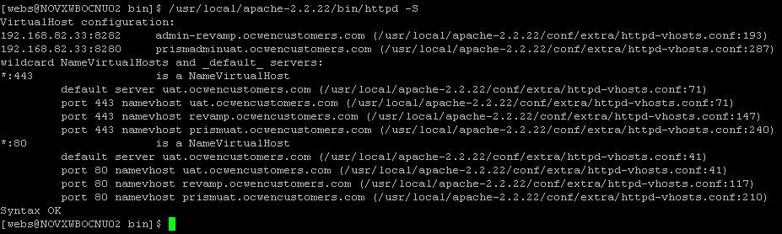
=================================000000=================================
=================================000000=================================

IP-based Virtual Hosts

IP-based virtual hosting is a method to apply different directives based on the IP address and port a request is received on. Most commonly, this is used to serve different websites on different ports or interfaces.

Note: In many cases, name-based virtual hosts are more convenient, because they allow many virtual hosts to share a single address/port.

As the term IP-based indicates, the server must have a different IP address/port combination for each IP-based virtual host. This can be achieved by the machine:
- Having several physical network connections,
- By use of virtual interfaces which are supported by most modern operating systems
- By using multiple port numbers.

In the terminology of Apache HTTP Server, using a single IP address but multiple TCP ports is also IP-based virtual hosting.

How to set up Apache
There are two ways of configuring apache to support multiple hosts:
- Either by running a separate httpd daemon for each hostname
- By running a single daemon which supports all the virtual hosts.
  - Single IP Two WebSites
  - Two IP’s Two WebSites

Single IP Two WebSites :
This is one of the most common setups. We will create two websites - www.ninjafather.com and ww.ninja-son.com. Both will reside on our server, which has the IP address 192.168.1.128. In order to make them both accessible to the world, we will create two VirtualHost blocks and declare their DocumentRoot and ServerName separately.

Here’s what we need to do:
- Create directories inside /var/www/html called ninja-father and ninja-son.
- Create simple index.html files for each.
- Edit httpd.conf and create our two VirtualHost blocks.

Now, for the sake of convenience, we will also use the /etc/hosts file to allow name resolution to work. It is also imperative in our case, because using the IP address would always point to the first VirtualHost listed in the httpd.conf file.
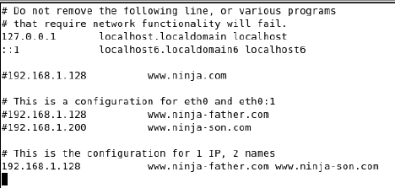
Create the Virtual Hosts as per our requirement:

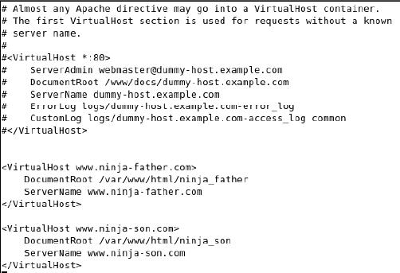

Save the file and restart apache to access the websites, respective HTML files would be retrieved as configured:

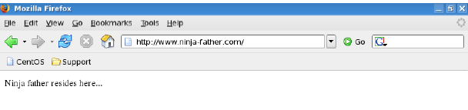

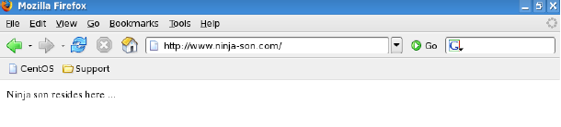

Two IP’s Two WebSites : This is another common scenario. You can assign a different IP to each website, avoid possible resolution mixups and simplifying your setup. However, this requires that you either use more than a single network adapter or create virtual adapters.
If you have, let’s say 14 websites, having 14 physical network devices plugged into your machines is not the best idea. Using virtual adapters is the most sensible choice here.
We already have our two websites ready. We just need to create a virtual network card and then change the httpd.conf file to reflect the changes. First, we will create a virtual adapter (eth0:1) with the IP address of 192.168.1.200.

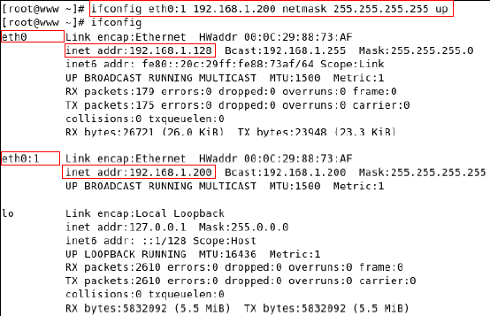

Edit httpd.conf file to make config changes:


Edit /etc/hosts file to enable name resolution to work:
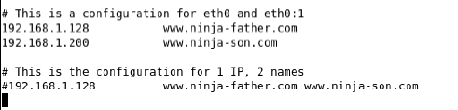
=================================000000=================================
=================================000000=================================
NameVirtualHost : The NameVirtualHost directive associates an IP address and port number, if necessary, for any name-based virtual hosts. Name-based virtual hosting allows one Apache HTTP Server to serve different domains without using multiple IP addresses.

Important: NameVirtualHost allows you to map named-based incoming connections to specific IP addresses. You might ask yourselves why you need this, when we have seen perfectly good examples before, without this feature. Well, the answer is: if somehow a named-based request gets “lost” (due to DNS configuration, firewall rules or similar), it might not match any of the VirtualHost blocks. In that case, the default settings configured in httpd.conf will be applied to this request, which could be contrary to your needs.
Using NameVirtualHost forces all incoming connections to a certain IP address to point to a certain VirtualHost block. This request will also never fall back to the main configuration, allowing you a complete modularity in your setup. Thus, in our example, all requests to the internal IP address will go the VirtualHost with this IP address declared.

Running several name-based web sites on a single IP address
Your server has a single IP address, and multiple aliases (CNAMES) point to this machine in DNS. You want to run a web server for www.example.com and www.example.org on this machine.

Note: Creating virtual host configurations on your Apache server does not magically cause DNS entries to be created for those host names. You must have the names in DNS, resolving to your IP address, or nobody else will be able to see your web site. You can put entries in your hosts file for local testing, but that will work only from the machine with those hosts entries.

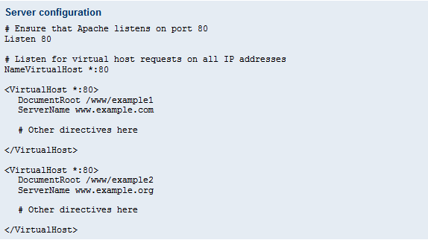
The asterisks match all addresses, so the main server serves no requests. Due to the fact that www.example.com is first in the configuration file, it has the highest priority and can be seen as the default or primary server. That means that if a request is received that does not match one of the specified ServerName directives, it will be served by this first VirtualHost.

Note: You can, if you wish, replace * with the actual IP address of the system. In that case, the argument to VirtualHost must match the argument to NameVirtualHost:

NameVirtualHost 172.20.30.40

<VirtualHost 172.20.30.40>
# Etc ...
However, it is additionally useful to use * on systems where the IP address is not predictable - for example if you have a dynamic IP address with your ISP, and you are using some variety of dynamic DNS solution. Since * matches any IP address, this configuration would work without changes whenever your IP address changes.

Name-based hosts on more than one IP address.
The server has two IP addresses. On one (172.20.30.40), we will serve the "main" server, server.domain.com and on the other (172.20.30.50), we will serve two or more virtual hosts.

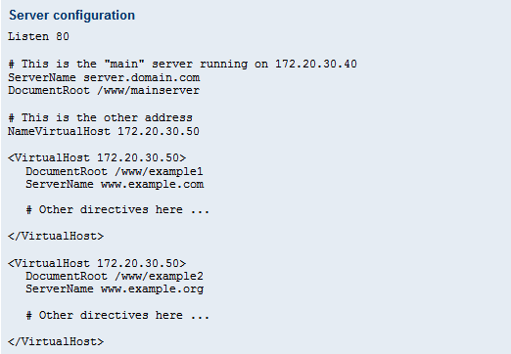

Any request to an address other than 172.20.30.50 will be served from the main server. A request to 172.20.30.50 with an unknown hostname, or no Host: header, will be served from www.example.com.

For more examples on vhosts visit following link:

http://httpd.apache.org/docs/2.2/vhosts/examples.html

=================================000000=================================
=================================000000=================================

Apache HTTPD and Tomcat Connector
Why connect HTTPD and Tomcat?
One question often asked by new Tomcat users is why Tomcat and HTTPD would need to communicate at all. After all, one of the features that make Tomcat so flexible is its ability to function as a standalone web server and application server, thanks to the Coyote component.
There are a number of reasons why you might need HTTPD and Tomcat to talk to one another. In the early days of Tomcat, one of the most common reasons to connect the two servers was to allow HTTPD to serve static content, freeing up Tomcat to process dynamic requests. However, performance improvements have made serving static content using Tomcat just as fast as on HTTPD (and sometimes faster, when the elimination of the extraneous connection is factored in).
Clustering, Load Balancing, and Security : HTTPD and mod_jk can be used to balance server load across multiple Tomcat instances, or divide Tomcat instances into various namespaces, managed by HTTPD.
Apache HTTPD Modules and Extensions : Apache HTTPD has been the most popular web server in the world since 1996. At this point, the number of modules that are available to extend its functionality is staggering. Need CGI? Adding it to Tomcat is going to take some elbow grease, but adding it to Apache is just a matter of installing downloading and installing a single module. Apache also can handle many different "decorations" - rewrites of headers, URLs, and more.
Socket Error Handling : Unlike Tomcat, Apache HTTPD can run natively on a system, rather than within a cross-platform JVM. For this reason, HTTPD has an advantage when it comes to handling socket errors (i.e. dropped/invalid connections, invalid IPs, etc), as socket optimization practices differ significantly from operating system to operating system.
Security : Tomcat and HTTPD are different projects, but in some areas - security, for example - their functionality overlaps.
In these cases, some users may decide to delegate these tasks to HTTPD. Usually, this decision is based on the fact that HTTPD has a much larger community than Tomcat, and thus has many more 'tricks up its sleeve' when it comes to these areas.
While this isn't an unreasonable line of logic, Tomcat is not inherently less secure than HTTPD. In fact, according to Apache, there has never been a reported case of data loss or damage due to a malicious attack on a Tomcat instance - not even one.
Ultimately, the decision to use HTTPD to handle security should be based on your specific use scenario. If you are facing a problem that has no existing solution in the Tomcat community, but has already been solved by the Apache HTTPD community, there's no reason not to integrate HTTPD into your toolkit.
The only caveat is that, as with any network component, an additional system means one more point of attack you must consider when securing your infrastructure.

Communication methodology used
Apache Tomcat uses Connector components to allow communication between a Tomcat instance and another party, such as a browser, server, or another Tomcat instance that is part of the same network. For example,
The HTTP connector listens for requests over the HTTP/1.1 protocol on various TCP ports, and forwards them to the Engine associated with processing the request.
mod_proxy_http : This module is an HTTP-specific version of the venerable mod_proxy module. It offers most of the same features as mod_jk, but communicates over the HTTP protocol. Although at one time the AJP protocol offered a significant performance boost over standard HTTP, this is no longer the case, so speed is no reason to choose one over the other.
The main reason for choosing mod_proxy_http over mod_jk is that if communication between HTTPD and Tomcat must be encrypted, mod_proxy_http may be easier to use. This is because mod_proxy_http can be configured to use the https protocol with a minute change to its configuration, whereas encryption with mod_jk requires extra work.
On the other hand, if your application requires SSL information, this is much easier to expose with mod_jk.
The AJP connector will help Apache Tomcat instances to exchange data with mod_jk enabled instances of Apache HTTPD, using the AJP protocol.
mod_jk : Implementations of mod_jk are also available for integration with IIS and NES/iPlanet/Sun, but are less widely used.
mod_proxy_ajp : This module is very similar to mod_jk, except that its configuration is consistent with that of other HTTPD modules, unlike mod_jk.

Apache Mod Proxy Configuration
Apache can be configured in both a forward and reverse proxy (also known as gateway) mode.
Forward Proxy : A typical usage of a forward proxy is to provide Internet access to internal clients that are otherwise restricted by a firewall. The forward proxy can also use caching (as provided by mod_cache) to reduce network usage.
The forward proxy is activated using the ProxyRequests directive. Because forward proxies allow clients to access arbitrary sites through your server and to hide their true origin, it is essential that you secure your server so that only authorized clients can access the proxy before activating a forward proxy.
Want to test this, turn ProxyRequests On and restart your Apache Web Server. Now open your web browser and enable a proxy server using your website as the address and port 80. Now open http://blog.phyber.com as you can see the site loaded as expected. Check out your access logs on your Web Server for confirmation you are using your Web Server as a Proxy Server.
Controlling access to your proxy : You can control who can access your proxy via the <Proxy> control block using the following example:
ProxyRequests On

<Proxy *>
Order Deny,Allow
Deny from all
Allow from 192.168.0
</Proxy>
When configuring a reverse proxy, access control takes on the attributes of the normal server <Directory> configuration.
Reverse Proxy : A reverse proxy (or gateway), by contrast, appears to the client just like an ordinary web server. No special configuration on the client is necessary. The client makes ordinary requests for content in the name-space of the reverse proxy. The reverse proxy then decides where to send those requests, and returns the content as if it was itself the origin.
A typical usage of a reverse proxy is to provide Internet users access to a server that is behind a firewall. Reverse proxies can also be used to balance load among several back-end servers, or to provide caching for a slower back-end server. In addition, reverse proxies can be used simply to bring several servers into the same URL space.
<VirtualHost *:80>
ServerName www.internalserver.com
ProxyRequests Off
ProxyPass / http://localhost:8080
ProxyPassReverse / http://localhost:8080
</VirtualHost>

The HTTP connector

ProxyPass Directive : This directive allows remote servers to be mapped into the space of the local server; the local server does not act as a proxy in the conventional sense, but appears to be a mirror of the remote server. The local server is often called a reverse proxy or gateway. The path is the name of a local virtual path; url is a partial URL for the remote server and cannot include a query string.

The ProxyRequests directive should usually be set off when using ProxyPass. Suppose the local server has address http://example.com/; then

ProxyPass /mirror/foo/i !
ProxyPass /mirror/foo/ http://backend.example.com/

will cause a local request for http://example.com/mirror/foo/bar to be internally converted into a proxy request to http://backend.example.com/bar.

The ! directive is useful in situations where you don't want to reverse-proxy a subdirectory, as seen above it will proxy all requests to /mirror/foo to backend.example.com except requests made to /mirror/foo/i.

In Apache HTTP Server 2.1 and later, mod_proxy supports pooled connections to a backend server. Connections created on demand can be retained in a pool for future use. Limits on the pool size and other settings can be coded on the ProxyPass directive using key=value parameters, described in the table below.

By default, mod_proxy will allow and retain the maximum number of connections that could be used simultaneously by that web server child process. Use the max parameter to reduce the number from the default. Use the ttl parameter to set an optional time to live; connections which have been unused for at least ttl seconds will be closed. ttl can be used to avoid using a connection which is subject to closing because of the backend server's keep-alive timeout.

The pool of connections is maintained per web server child process, and max and other settings are not coordinated among all child processes, except when only one child process is allowed by configuration or MPM design.

Example
ProxyPass /example http://backend.example.com max=20 ttl=120 retry=300

http://httpd.apache.org/docs/2.2/mod/mod_proxy.html
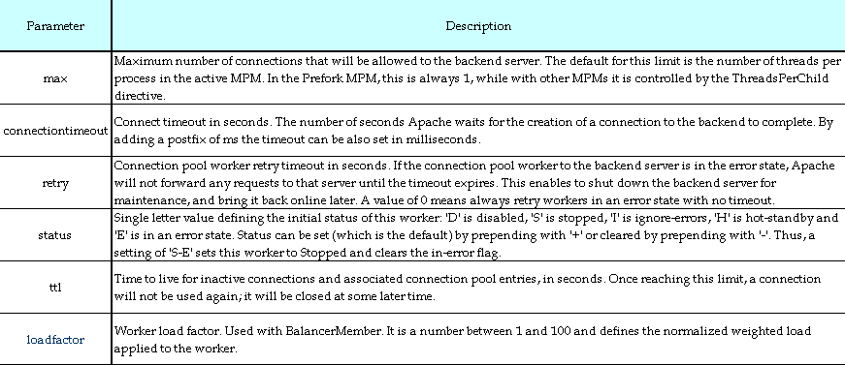

If the ProxyPass directive scheme starts with the balancer:// (eg: balancer://cluster/, any path information is ignored) then a virtual worker that does not really communicate with the backend server will be created. Instead it is responsible for the management of several "real" workers. In that case the special set of parameters can be add to this virtual worker.

Other useful mod_proxy examples include load balancing to multiple backend hosts. In this example we will be proxying traffic to two backend servers using the cookie JSESSIONID for sticky sessions.

<Proxybalancer://mycluster>
BalancerMember http://server01:8080 stickysession=JSESSIONID
BalancerMember http://server02:8081 stickysession=JSESSIONID
# BalancerMember ajp://server01:8009 stickysession=JSESSIONID
# BalancerMember ajp://server02:8009 stickysession=JSESSIONID
</Proxy>

ProxyPass /webapp balancer://mycluster/webapp
ProxyPassReverse /webapp balancer://mycluster/webapp

Note in this configuration using mod_proxy_ajp a ProxyPassReverse is not needed as the AJP request includes the original host given to the proxy, and the application server can respond properly so no rewriting of the host request is required.

http://httpd.apache.org/docs/2.2/mod/mod_proxy_balancer.html
http://httpd.apache.org/docs/2.2/mod/mod_proxy.html

=================================000000=================================
=================================000000=================================

The AJP connector

Follow the steps below to configure AJP Connector in httpd.conf file :

LoadModule jk_module path/to/mod_jk.so

JkWorkersFile conf/extra/worker.properties
JkLogFile logs/mod_jk.log
JkLogLevel info
JkLogStampFormat "[%a %b %d %H:%M:%S %Y] "

cat worker.properties
worker.list=prismloadbalancer,gogreenloadbalancer,hibernateloadbalancer,prismuatloadbalancer,loadbalancer,node1

worker.node1.port=8109
worker.node1.host=192.168.82.33
worker.node1.type=ajp13
worker.node1.lbfactor=1

worker.prismloadbalancer.type=lb
worker.prismloadbalancer.balanced_workers=prismnode1,prismnode2
worker.prismloadbalancer.sticky_session=1

JkMount /* node1
#JkMount /* hibernateloadbalancer
JkMount /* prismuatloadbalancer

http://www.openlogic.com/wazi/bid/188014/Tune-mod_jk-to-Boost-HTTP-Java-Server-Performance

http://tomcat.apache.org/tomcat-3.2-doc/mod_jk-howto.html

MOD_PROXY vs MOD_JK
http://blog.contegix.com/2009/02/02/mod-proxy-ajp-versus-mod-jk-round-1/

=================================000000=================================
=================================000000=================================

Redirect : When a webpage is moved, Redirect can be used to map the file location to a new URL. The format is as follows:

Redirect /<old-path>/<file-name> http://<current-domain>/<current-path>/<file-name>

In this example, replace <old-path> with the old path information for <file-name> and <current-domain> and <current-path> with the current domain and path information for <file-name>.
In this example, any requests for <file-name> at the old location is automatically redirected to the new location.

=================================000000=================================
=================================000000=================================

Apache Rewrite Techniques
The Apache Rewrite feature is a really sophisticated which provides a powerful way to do URL manipulations like:

- Solve Trailing Slash Problem
- Solve Moved DocumentRoot Problem
- Solve Moved Homedirs to Different Webserver Problem
- Solve Filesystem Reorganisation Problem
- Redirect Homedirs For Foreigners
- Redirect Failing URLs To Other Webserver
- From Old to New (intern)
- From Old to New (extern)
- Search pages in more than one directory
- .... and many more ....

The Rewrite Feature is provided by mod_rewrite module of apache.

mod_rewrite is an Apache module that allows for server-side manipulation of requested URLs. Incoming URLs are checked against a series of rules. The rules contain a regular expression to detect a particular pattern. If the pattern is found in the URL, and the proper conditions are met, the pattern is replaced with a provided substitution string or action. This process continues until there are no more rules left or the process is explicitly told to stop.

This is summarized in these three points:

- There are a list of rules that are processed in order.
- If a rule matches, it checks the conditions for that rule.
- If everything is a go, it makes a substitution or action.

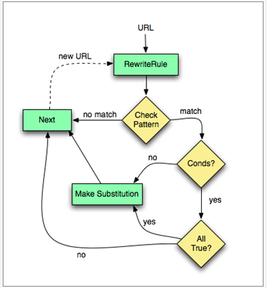
This is the most classic rewrite rule. The following script will listen for anyone who comes to your website via http://www.example.com. Those who do will receive a hard redirect, and, thus, the location bar in their browser will update accordingly.

RewriteEngine on
RewriteCond %{HTTP_HOST} ^www\.example\.com$ [NC]
RewriteRule ^(.*)$ http://example.com/$1 [R=301,L]

The RewriteRule above matches anything, and saves it as $1 – as specified by the wrapping parenthesis. The important part in this example, though, is the RewriteCond. This condition checks the HTTP_HOST variable to determine if it started with “www.” [NC] stands for nocase. If this condition is true, the rewrite occurs:

- The substitution is a full URL (it starts with http://)
- The substitution contains $1, which was captured earlier
- The [R=301] flag redirects the browser to the rewritten URL. This is a hard redirect in the sense that it forces the browser to load the new page and update its location bar with the new URL.
- The [L] flag indicates that this is the last rule to parse. Beyond this line, the rewrite engine should stop.

If the incoming URL had been “http://www.example.com/user/index.html”, then HTTP_HOST would have been set to www.example.com and the rewrite would trigger, creating http://example.com/user/index.html.

On the other hand, If the incoming URL had been “http://example.com/user/index.html”, then HTTP_HOST would have been example.com, the condition would fail, and the rewrite engine would proceed with the URL unchanged.

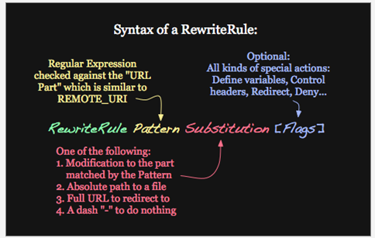
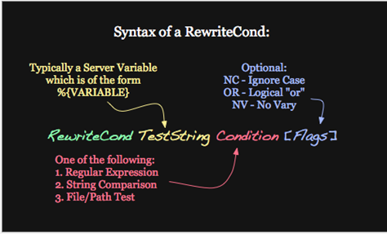

RewriteEngine on
RewriteCond %{HTTP_REFERER} !^http://example\.net/?.*$ [NC]
RewriteCond %{HTTP_REFERER} !^http://example\.com/?.*$ [NC]
RewriteRule \.(gif|jpe?g|png|bmp)$ – [F,NC]
#RewriteRule \.(gif|jpe?g|png|bmp)$ http://example.com/warning.png [R,NC]
#RewriteRule .* custom_404.html [L]

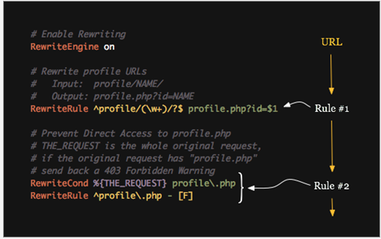

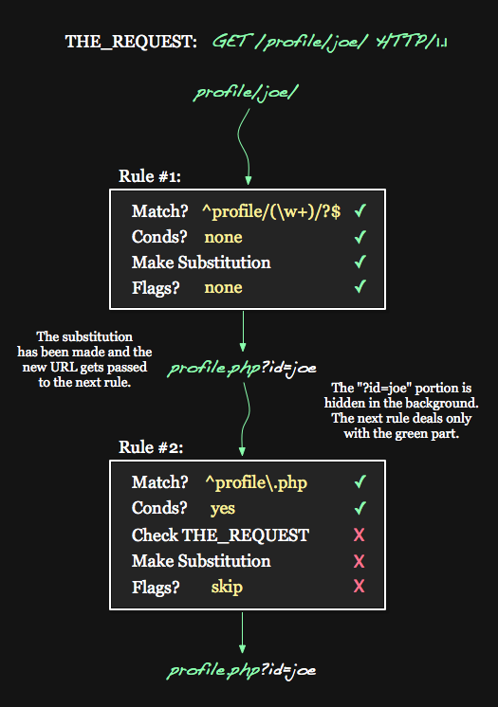

Examples :

RewriteEngine on
RewriteRule ^widget/(.*)$ http://product.example.com/widget/$1 [P]
ProxyPassReverse /products/widget/ http://product.example.com/widget/

RewriteCond %{REQUEST_FILENAME} !-f
RewriteCond %{REQUEST_FILENAME} !-d
RewriteRule ^/(.*) http://old.example.com/$1 [P]
ProxyPassReverse / http://old.example.com/

In each case, we add a ProxyPassReverse directive to ensure that any redirects issued by the backend are correctly passed on to the client.

For more examples refer : https://httpd.apache.org/docs/trunk/rewrite/remapping.html

http://httpd.apache.org/docs/2.2/rewrite/
http://www.sitepoint.com/guide-url-rewriting/
http://httpd.apache.org/docs/2.2/rewrite/intro.html
http://httpd.apache.org/docs/2.2/rewrite/flags.html

=================================000000=================================
=================================000000=================================
Cache Directives: A number of commented cache directives are supplied by the default Apache HTTP Server configuration file. In most cases, uncommenting these lines by removing the hash mark (#) from the beginning of the line is sufficient. The following, however, is a list of some of the more important cache-related directives.
CacheEnable — Specifies whether the cache is a disk, memory, or file descriptor cache. By default CacheEnable configures a disk cache for URLs at or below /.
CacheRoot — Specifies the name of the directory containing cached files. The default CacheRoot is the /var/httpd/proxy/ directory.
CacheSize — Specifies how much space the cache can use in kilobytes. The default CacheSize is 5 KB.
The following is a list of some of the other common cache-related directives.
CacheMaxExpire — Specifies how long HTML documents are retained (without a reload from the originating Web server) in the cache. The default is 24 hours (86400 seconds).
CacheLastModifiedFactor — Specifies the creation of an expiry (expiration) date for a document which did not come from its originating server with its own expiry set. The default CacheLastModifiedFactor is set to 0.1, meaning that the expiry date for such documents equals one-tenth of the amount of time since the document was last modified.
CacheDefaultExpire — Specifies the expiry time in hours for a document that was received using a protocol that does not support expiry times. The default is set to 1 hour (3600 seconds).
NoProxy — Specifies a space-separated list of subnets, IP addresses, domains, or hosts whose content is not cached. This setting is most useful for Intranet sites.

http://httpd.apache.org/docs/2.2/caching.html
http://httpd.apache.org/docs/trunk/mod/mod_cache.html
http://httpd.apache.org/docs/2.2/mod/mod_file_cache.html
http://httpd.apache.org/docs/2.2/mod/mod_disk_cache.html
http://httpd.apache.org/docs/2.2/mod/mod_mem_cache.html

=================================000000=================================
=================================000000=================================

